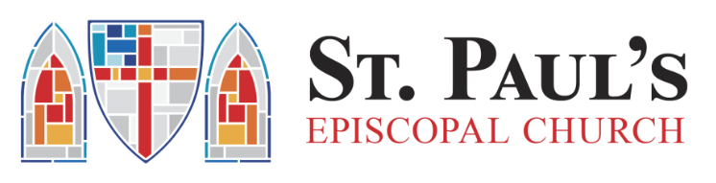

St. Paul’s Church
Remote Job:
Communications and Project Assistant 6 hrs/wk $30 per hour
St. Paul’s is a small but vital congregation in south St. Louis. Starting this year, we are targeting congregational growth in two demographic areas: members of the Latino American community and young creatives. To support that effort, we are looking for a Communications Coordinator for our parish. The work will be collaborative with plenty of room for you to share ideas and strategies. Your professional voice and opinions will be encouraged, valued, and utilized. You will have the opportunity to help shape our vision and enjoy the fruits of measurable impacts as we achieve our goals.
Required: creativity, team player, detail-oriented, self-motivated, able to consistently meet deadline, able to communicate concisely and effectively. A positive outlook on life. Proven competency with communications platforms and software
Specifics about the work:
Hours: 6 hrs a week
Wage: $30 an hour
Entirely remote with opportunities for onsite presence as desired.
website: www.carondeletchurch.org

Competencies Needed:
Communications (80% of work)
Facility with Instagram, Facebook, Twitter, Tik Tok, Eventbrite, Zoom, and capacity to engage emerging online platforms that are specifically preferred by our targeted demographic. Proven capacity to engage, influence and recruit others to participate through social media.
Experience with promoting events, identifying success measures, and evaluating outcomes post-event with the goal of improving communications for subsequent efforts.
Capacity to write clearly and engagingly.
Capacity to edit and evaluate content.
Willingness to ‘hover’ on platforms to promote content.
Work with the Rector/Sr. Pastor to populate the weekly newsletter and worship reminder.
Coordination (20%)
Work with outreach teams to target and effectively complete goals.
Including but not necessarily limited to:
Attending zoom meetings
Ensuring follow up and coordinating platforms for accountability on tasks (ie Trello/Monday supervision)
Please send a letter of interest explaining what appeals to you about the position, and resume to: Rebecca Ragland at: pastorragland@gmail.com

